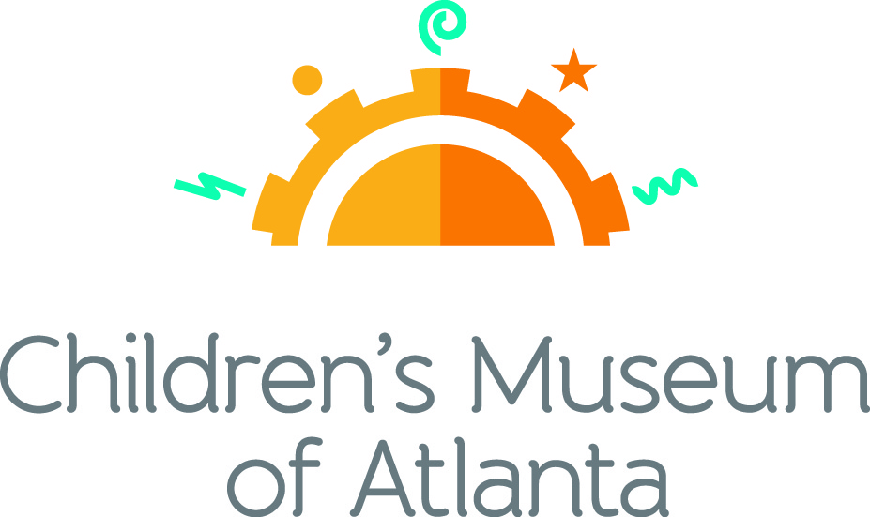

CONTACT
Becca Meyer/Jennifer Walker
BRAVE PR, 404.233.3993
bmeyer@bravepublicrelations.com/
jwalker@bravepublicrelations.com
FOR IMMEDIATE RELEASE

Children’s Museum of Atlanta launches value days
New dynamic pricing system offers deals for advance online ticket buyers

ATLANTA (December 15, 2017) – Children’s Museum of Atlanta announced today that it will initiate value days as part of its new dynamic pricing system. Beginning December 15, guests will have the opportunity to purchase tickets online for as low as $12.95 on select days. The dynamic pricing will also allow patrons to save and guarantee admission with advance online purchases. Visitors who choose to pay onsite will still experience affordable admission pricing ranging from $15.95 to $18.95.

“As Atlanta’s premier source of fun-filled learning for children, we want to make sure that everyone has the chance to conveniently experience the city’s only educational venue of this kind,” said Jane Turner, executive director of Children’s Museum of Atlanta. “With the introduction of value days, our hope is that more families will have the chance to enjoy our immersive exhibits and special programming!”

Kids are invited to revel in the holiday magic and learn about Christmas and Kwanzaa through special Celebrations in Light programming on December 23 and 26. In 2018, families can expect a variety of engaging programming at the Museum! From January 27-May 28, the vibrant community of Healthyville will make a stop at Children’s Museum of Atlanta to provide hands-on opportunities for children and adults to explore how nutrition and fitness affects the human body. In addition, little ones can learn about Dr. Martin Luther King with special programming on January 15, including a moving recital of Dr. King’s “I Have a Dream” speech by Imaginator Jerry G. White.

For more information or to review upcoming value days, visit childrensmuseumatlanta.org.

###

About Children’s Museum of Atlanta:
Children’s Museum of Atlanta is the only educational venue of its kind in Atlanta, presenting educational programs and exhibits designed for young children ages 0-9. The Museum’s mission is to spark imagination and inspire discovery and learning for all children through the power of play. With six permanent learning zones consisting of bright, creative and hands-on exhibits, the Museum supports inventive play-based exploration and experiential learning focused on the whole child. Core competencies for literacy, math and science are promoted throughout all exhibits and programming in alignment with the state and national Core Performance Standards. Children’s Museum of Atlanta also offers parties, memberships, field trips, summer camp and private events. For more information or to support Children's Museum of Atlanta, visit childrensmuseumatlanta.org or call 404.659.KIDS [5437].

Museum Admission: Plan ahead and save! Families can purchase timed tickets online to save money and guarantee entry to the Museum. Babies under 12 months and members are admitted for free. All daily programs are included in price of admission. Group rates and military discounts are available. For more information regarding ticket and membership options, visit childrensmuseumatlanta.org.

Museum Hours: Monday, Tuesday, Thursday and Friday 10:00 a.m. – 4:00 p.m.; Saturday and Sunday 10:00 a.m. – 5:00 p.m.; Closed on Wednesdays. Please check the Museum website to confirm hours of operation.

Facebook: https://www.facebook.com/childrensmuseumatlanta
Twitter: https://twitter.com/ChildMuseumATL
Instagram: https://www.instagram.com/childrensmuseumatlanta
Pinterest: http://pinterest.com/cmatlanta

